Task 3: Wireshark Packet Analysis
Cybersecurity Internship Task Report | Student: Dilkhush Panchal

1. Objective
Understand how packet capture tools display network communications and how to recognize HTTP, DNS, TCP handshakes, and basic suspicious patterns. This report uses simulated packet examples; it does not claim that a live capture was performed.

2. Tools and Environment
• Wireshark packet analysis tool
• A device/network that you have permission to monitor
• Simulated packet rows for explanation

3. Sample Packet List
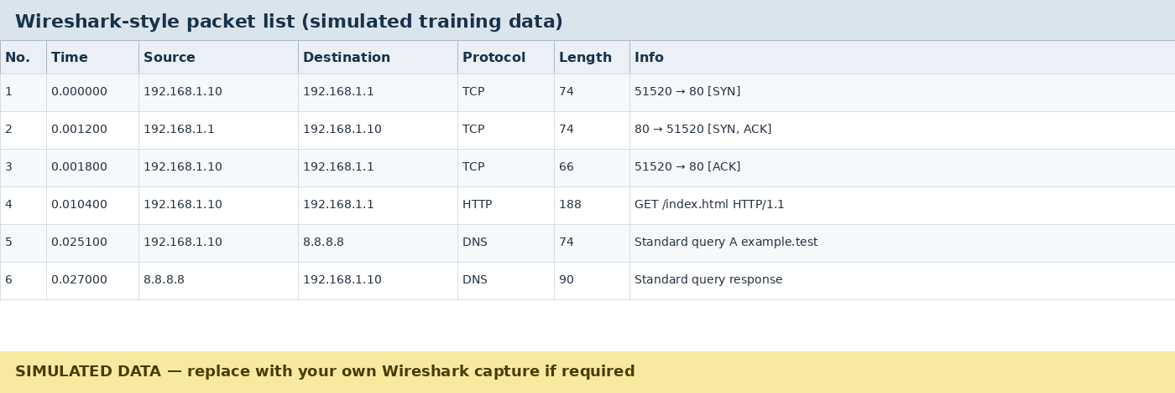
Figure 1. Simulated Wireshark-style packet list. Addresses and packets are sample training data, not a real capture.
The sample shows TCP connection setup, an HTTP GET request, and a DNS query followed by a response. Protocol and Info columns help identify traffic types.

4. TCP Handshake
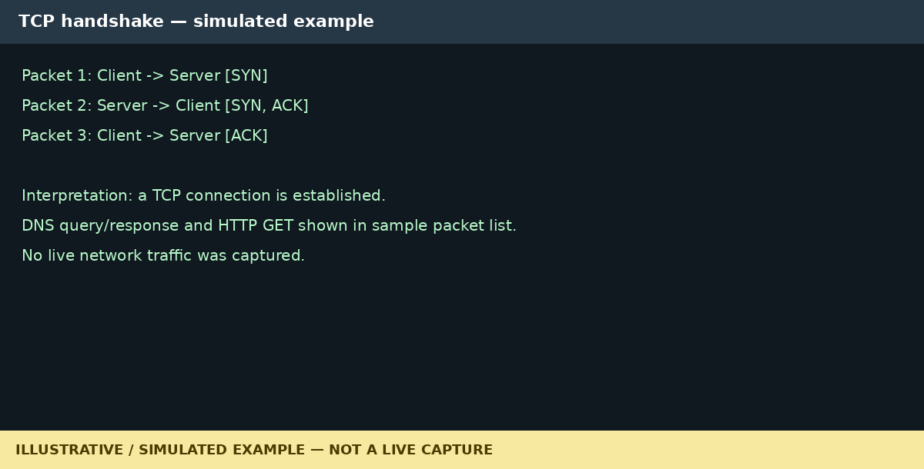
Figure 2. Simulated TCP handshake explanation.
A typical TCP three-way handshake is SYN from the client, SYN-ACK from the server, and ACK from the client. It establishes a TCP connection before application data is exchanged.

5. Protocol Observations
- TCP: SYN, SYN-ACK, and ACK are consistent with connection setup.
- HTTP: The sample contains an HTTP GET request. Plain HTTP is not encrypted, so contents may be visible to an observer on an authorized capture path.
- DNS: The sample shows a query for a hostname and a corresponding response.
- Suspicious traffic: This small simulated sample does not demonstrate malicious traffic. Real analysis may look for repeated failed connections, unexpected destinations, unusual ports, DNS anomalies, and unusual traffic volume.

6. Useful Packet Fields and Flags
Useful details include source/destination addresses, ports, protocol, length, timestamps, and TCP flags such as SYN, ACK, FIN, and RST. Interpret these fields in context; one packet alone does not prove an attack.

7. Safe Capture Procedure
- Open Wireshark and select an interface you are authorized to monitor.
- Start a short capture while performing ordinary activity, such as opening a trusted page or making a DNS lookup.
- Stop the capture and inspect traffic with display filters such as dns, tcp, http, or tls.
- Avoid collecting other people's private traffic and do not share captures containing passwords, session cookies, or personal information.
- Save sanitized screenshots or captures only if required and permitted.

8. Conclusion
This report explains basic packet-analysis concepts and common protocol patterns. Figures are simulated training data. If actual Wireshark evidence is required, replace the sample figures with genuine screenshots from a permitted capture.

9. References
• Wireshark User Guide: https://www.wireshark.org/docs/wsug_html_chunked/
• Wireshark Display Filter Reference: https://www.wireshark.org/docs/dfref/
• RFC 9293 — TCP: https://www.rfc-editor.org/rfc/rfc9293

